ServiceNow Project Documentation

Project Title:
Laptop Request Catalog Item
Team ID: LTVIP2026TMIDS34875
Team Members :
- N V Naga Rohini
- P S Usha Rani
- P Madhu Babu

Faculty Mentor(s) name: Sunitha I

Problem Statement:
Employees in the organization need a quick and efficient way to request laptops for work. The current process is manual and prone to delays, with no dynamic form behavior to guide users or ensure accurate data collection. To address this, a Service Catalog item needs to be created, allowing users to easily request a laptop, with dynamic fields, clear instructions, and additional functionality like resetting the form if needed. The solution should also ensure all changes are tracked for governance and deployment.

1. INTRODUCTION
1.1 Project Overview
ServiceNow is a cloud-based platform used for digital workflow automation and IT service management. The Service Catalog module in ServiceNow enables organizations to provide standardized services to employees through a user-friendly interface.
This project focuses on creating a Laptop Request Catalog Item that allows employees to request laptops efficiently. The solution includes dynamic form behaviour, validation, reset functionality, and deployment using Update Sets.

1.2 Purpose
The purpose of this project is to replace the existing manual laptop request process with an automated and dynamic solution using ServiceNow.
The key objectives are:
- To simplify laptop request submission
- To ensure accurate data collection
- To implement dynamic field behavior
- To enable form reset functionality
- To track changes using Update Sets for governance and deployment

2. IDEATION PHASE
2.1 Problem Statement
Employees in the organization need a quick and efficient way to request laptops for work. The current process is manual and prone to delays, with no dynamic form behavior to guide users or ensure accurate data collection. To address this, a Service Catalog item needs to be created, allowing users to easily request a laptop, with dynamic fields, clear instructions, and additional functionality like resetting the form if needed. The solution should also ensure all changes are tracked for governance and deployment.

2.2 Brainstorming
During brainstorming, the following ideas were identified:
- Required fields: Laptop Model, Justification
- Optional feature: Additional Accessories
- If accessories are selected → Accessories Details must appear
- Accessories Details must be mandatory when visible
- A Reset button should clear the form instantly
- All configurations must be tracked using Update Sets
- Export and import functionality should be tested in another instance

3. REQUIREMENT ANALYSIS
3.1 Functional Requirements
- Create a Local Update Set
- Create a Service Catalog Item named "Laptop Request"
- Add variables:
  - Laptop Model (Single Line Text)
  - Justification (Multi Line Text)
  - Additional Accessories (Checkbox)
  - Accessories Details (Multi Line Text)
- Create a Catalog UI Policy to show Accessories Details when checkbox is selected
- Make Accessories Details mandatory when visible
- Create a UI Action (Reset Form)
- Export Update Set to XML
- Retrieve and Commit Update Set in another instance
- Test functionality

3.2 Technology Stack
- ServiceNow Personal Developer Instance (PDI)
- Service Catalog Module
- Update Sets
- Catalog UI Policies
- UI Actions
- GitHub (for project submission)
- Screen Recorder (for demo video)

4. PROJECT DESIGN
4.1 Proposed Solution
The solution workflow is as follows:
User → Opens Service Catalog → Selects Hardware → Clicks Laptop Request → Fills form →
If Additional Accessories is checked → Accessories Details becomes visible and mandatory →
User can reset form using Reset Button →
All changes are tracked using Update Set →
Update Set exported as XML → Imported and committed in another instance.

4.2 Solution Architecture
User
↓
Service Catalog
↓
Laptop Request Catalog Item
↓
Variables
↓
Catalog UI Policy
↓
UI Action
↓
Update Set (Export & Retrieve)

5. PROJECT PLANNING
The project was implemented in structured phases:
- Step 1: Created Local Update Set
- Step 2: Created Service Catalog Item
- Step 3: Added Variables
- Step 4: Created Catalog UI Policy
- Step 5: Created UI Action (Reset Form)
- Step 6: Exported Update Set
- Step 7: Retrieved and Committed Update Set
- Step 8: Tested functionality

6. FUNCTIONAL TESTING
The following tests were performed:
✔ Test Case 1:
When "Additional Accessories" checkbox is selected →
"Accessories Details" becomes visible.
✔ Test Case 2:
When Accessories Details is visible →
Field becomes mandatory.
✔ Test Case 3:
Reset Form button clears all form fields.
✔ Test Case 4:
Update Set contains all configurations.
✔ Test Case 5:
Retrieved Update Set successfully committed in target instance.
All test cases passed successfully.
The implementation was validated in both source and target instances after committing the update set.

7. RESULTS
The Laptop Request Catalog Item was successfully created with dynamic form behavior and reset functionality.
The Update Set was exported, retrieved, previewed, and committed successfully in another instance.
The solution met all functional requirements as per SmartInternz guidelines.

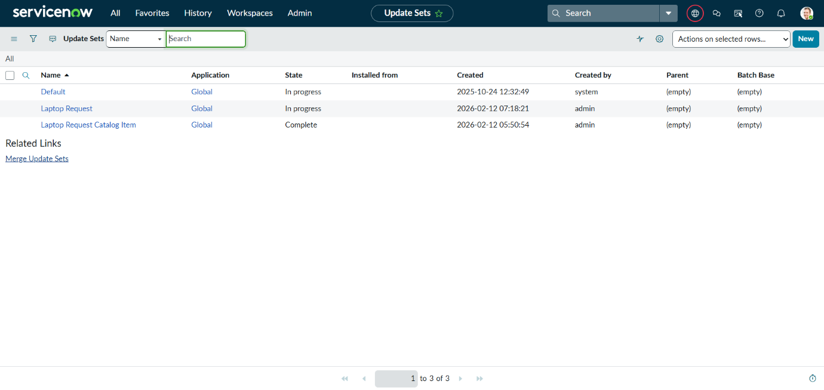
Fig 1: Local Update Set Creation

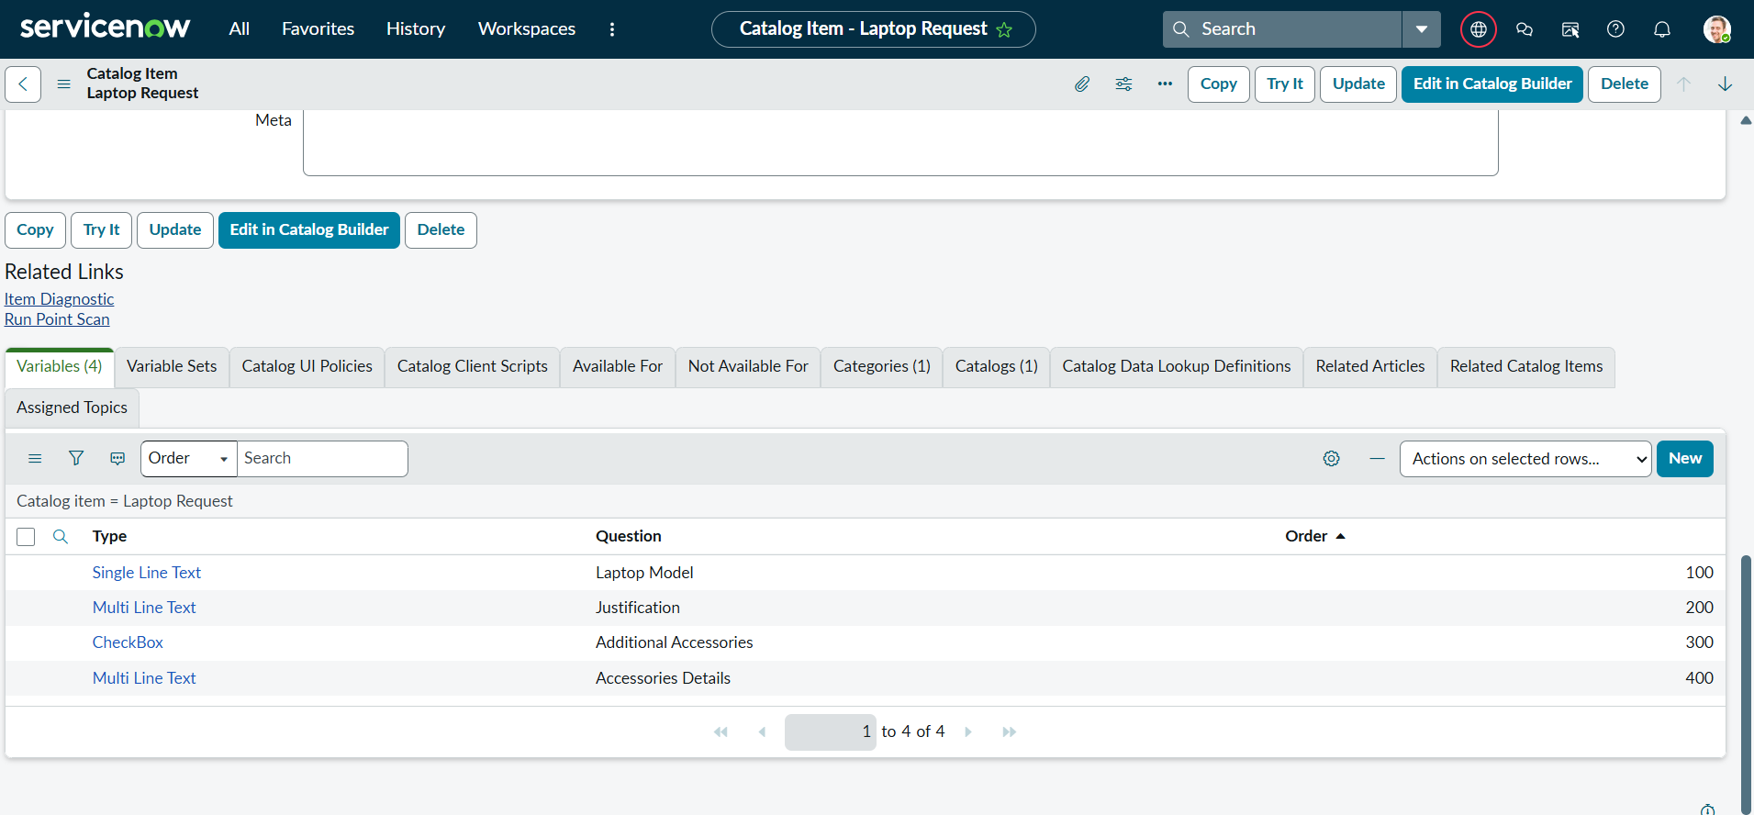
Fig 2: Laptop Request Catalog Item

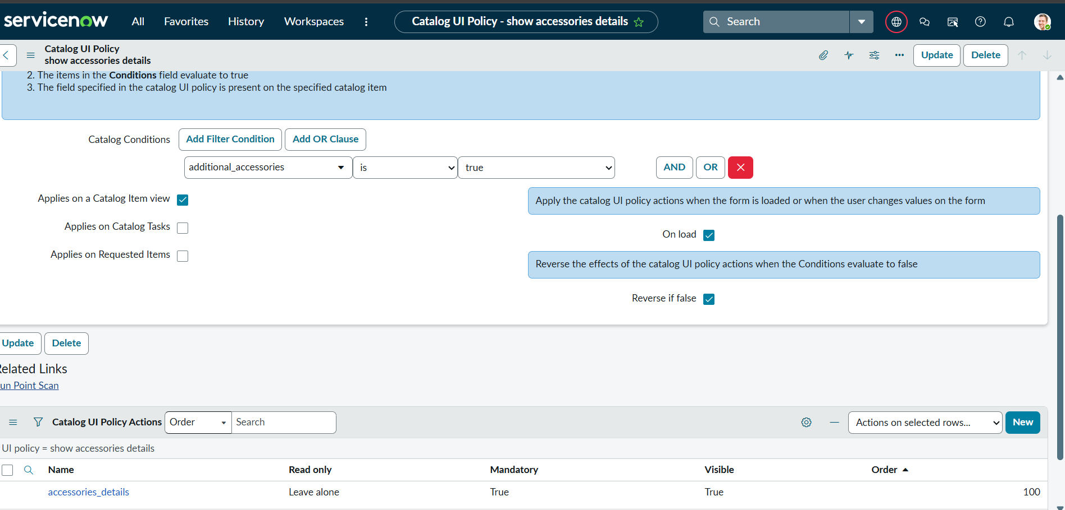
Fig 3: Catalog UI Policy

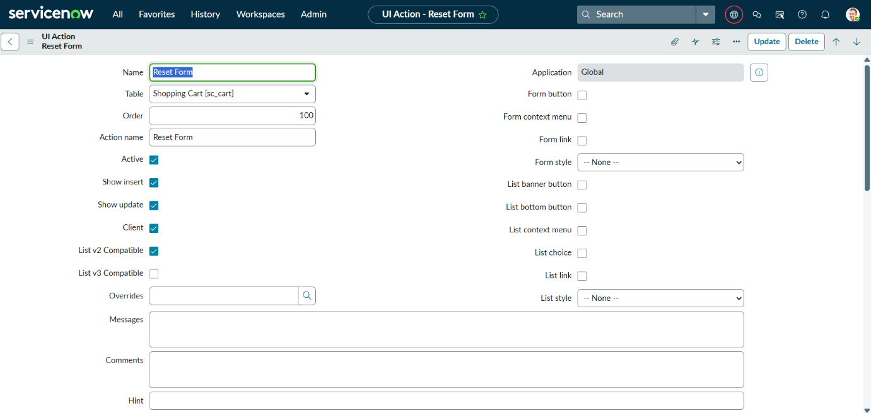
Fig 4: UI action (Reset Form)

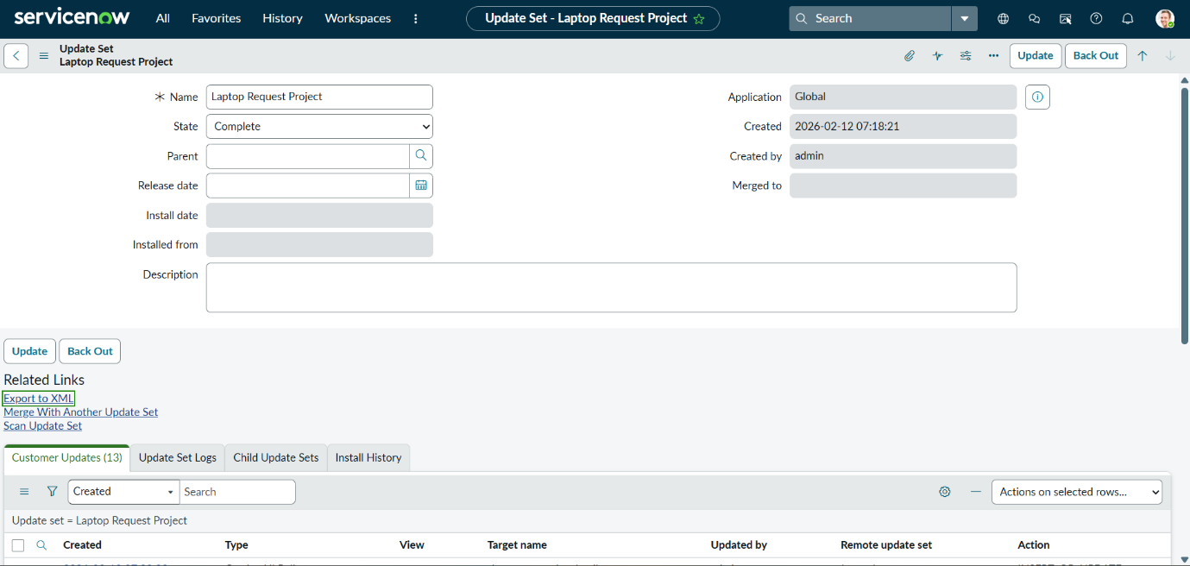
Fig 5: Exported Update Set (XML)

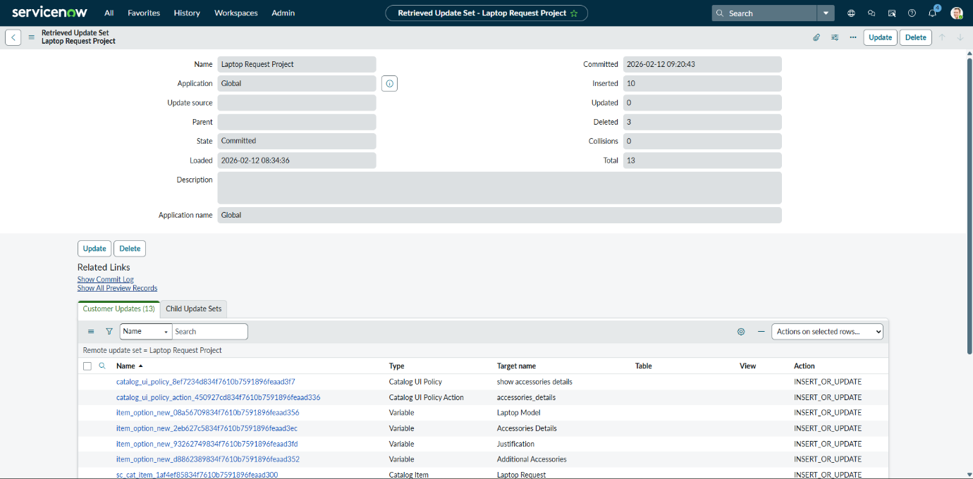
Fig 6: Retrieved & Committed Update Set
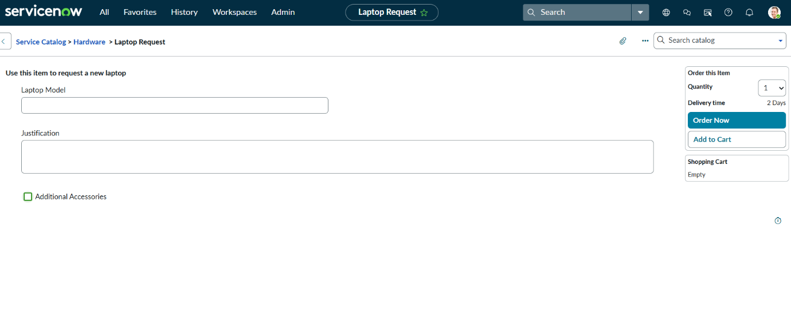
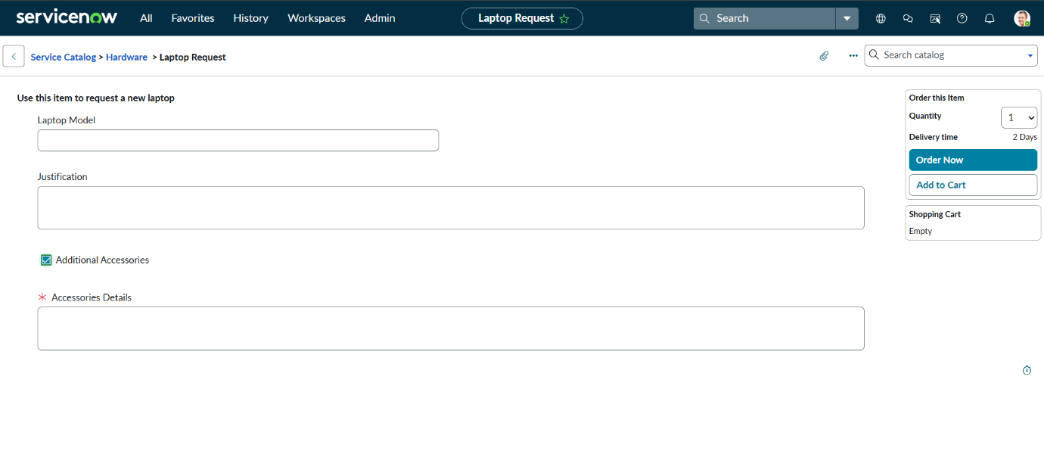
Fig 7: Testing – Accessories Checkbox Behaviour
8. ADVANTAGES
- Simplifies laptop request process
- Improves data accuracy
- Dynamic validation improves user experience
- Easy deployment using Update Sets
- Reduces manual errors
- Enhances governance and configuration tracking

9. CONCLUSION
The Laptop Request Catalog Item project successfully streamlines the process of requesting laptops within the organization by leveraging ServiceNow's Service Catalog capabilities. Through the implementation of a dynamic catalog item, the project ensures that users have an intuitive and user-friendly interface, reducing errors and improving efficiency. This project demonstrates how ServiceNow can be used to replace manual, error-prone processes with automated, efficient, and user-centric solutions. It not only improves service delivery but also enhances employee satisfaction by providing a modern and streamlined request experience.

10. FUTURE SCOPE
- Add Manager Approval Workflow
- Integrate with Asset Management Module
- Add Role-Based Access Control
- Enable Email Notifications
- Add SLA tracking

11. APPENDIX
- GitHub Repository Link:
https://github.com/NelabhotlaVenkataNagaRohini/Laptop-Request-Catalog-Item-ServiceNow
- Demo Video Link: https://drive.google.com/file/d/11IVpQHp9Sj2Zljf95VWNIQSmclemv7lJ/view?usp=sharing
- Update Set XML File: Laptop_Request_Project.xml

